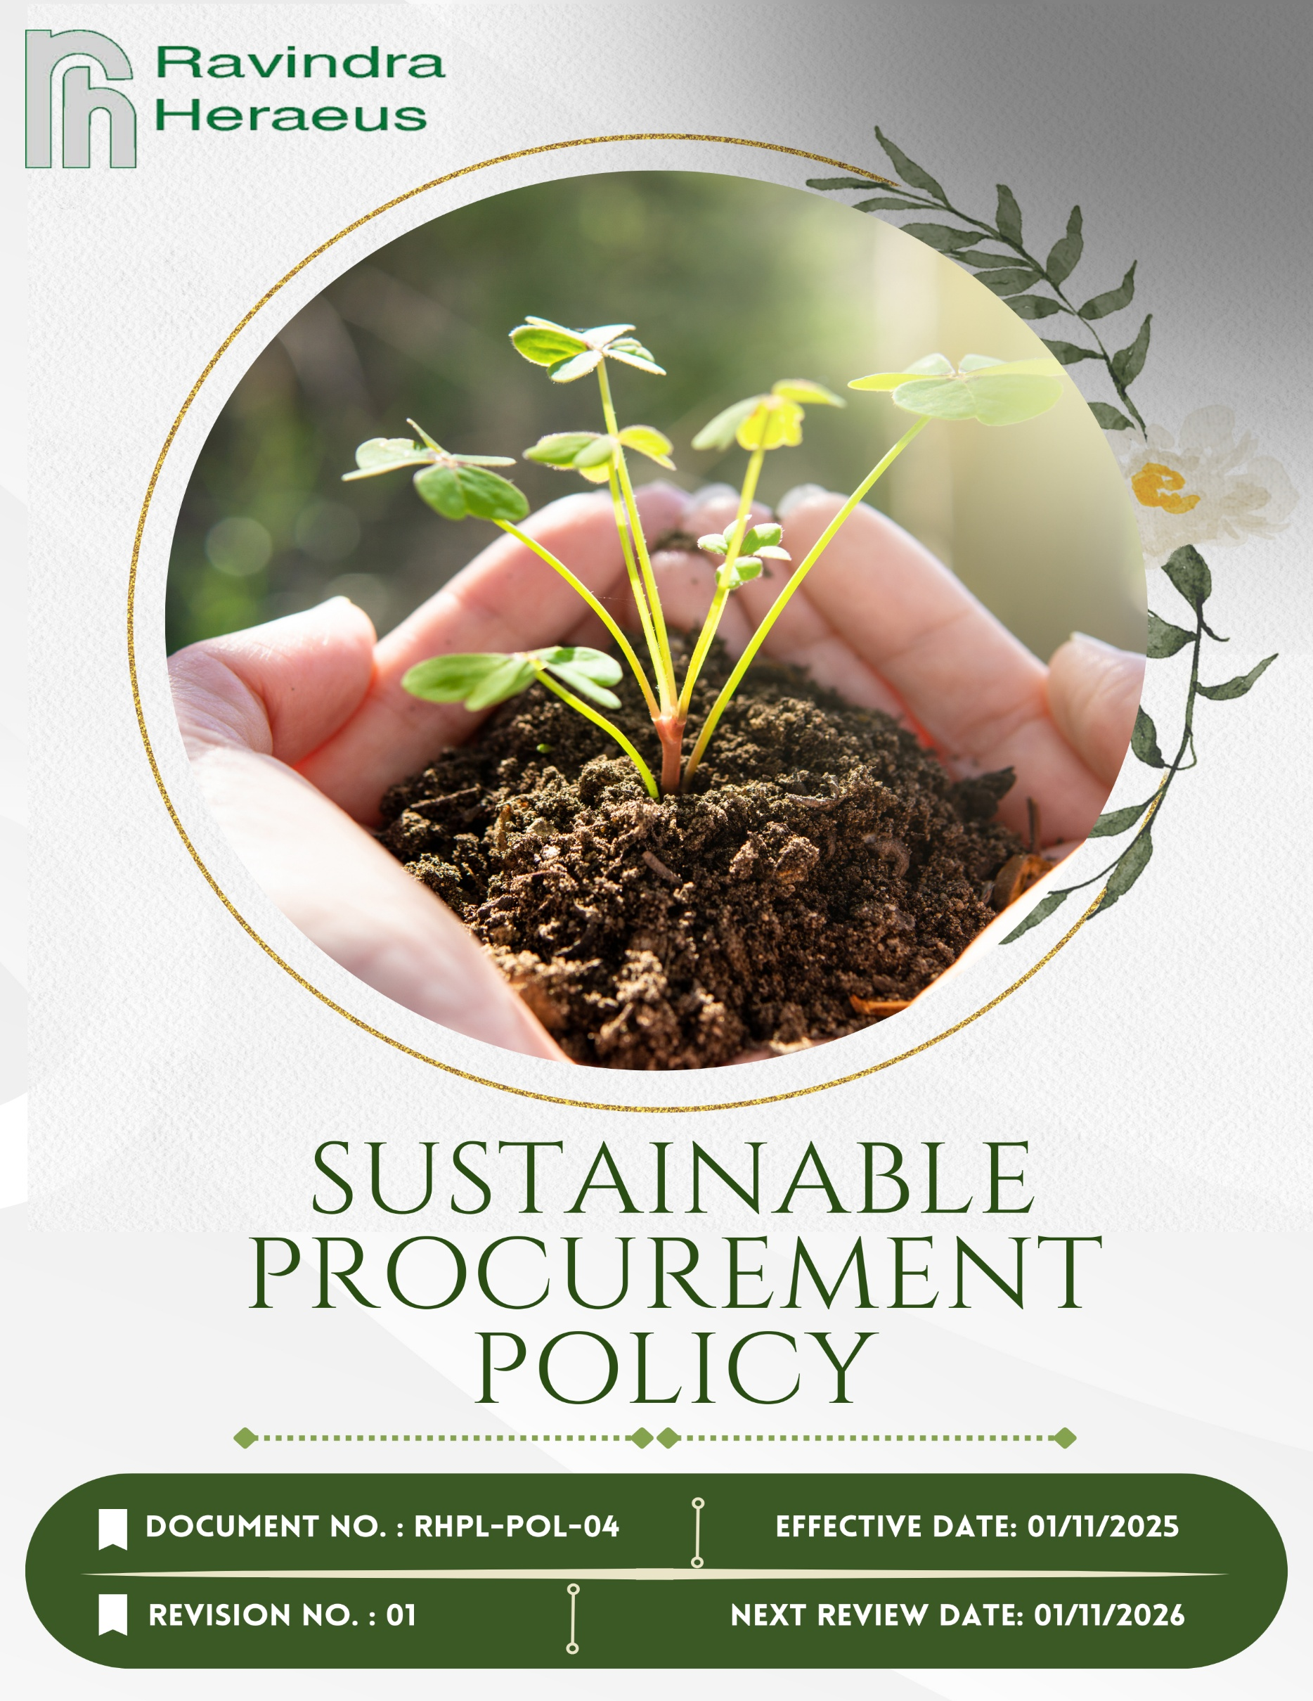
Contents

Preface 3
Policy Declaration 3
Scope 3
Key Focus Areas 4
Qualitative Objectives 4
Quantitative Targets 6
Alignment with the United Nations Sustainable Development Goals (SDGs) 7
Responsibilities 7
Review Mechanism 8
Employee Acknowledgment Form 9

Preface
At RAVINDRA HERAEUS PVT. LTD., we recognize sustainable procurement as a key element of its corporate responsibility and long-term business success. The company sources materials and services exclusively from approved suppliers, integrating sustainability as a critical criterion in all evaluation, selection, and contract award processes. RHPL’s commitment to responsible sourcing is further reinforced through its LPPM accreditation and alignment with global sustainability standards, including UN-based principles. These frameworks ensure that ethical, transparent, and environmentally responsible practices are upheld across the entire supply chain.

Policy Declaration
Ravindra Heraeus Pvt. Ltd. pledges to integrate sustainability criteria into every procurement decision. We will work with suppliers who share our commitment to environmental responsibility, ethical labor and social standards, transparency, and traceability. We commit to minimizing ecological impact, optimizing resource and material use (especially precious metals), promoting circular-economy practices (recycling, re-use, refining), and ensuring ethical sourcing throughout the value chain.

Scope
This policy applies to all sourcing and procurement activities at RHPL, including raw materials, components, and services. It extends to the entire supply chain, covering suppliers, contractors, and business partners and ensures responsible practices related to labor, environment, compliance, and human rights across all regions of operation.

Site | Address
Ravindra Heraeus Pvt. Ltd. | A -196 (A), F Road, Madri Industrial Area, Udaipur - 313001, Rajasthan, India.

Key Focus Areas
- Environmentally Responsible sourcing: Prioritize procurement of materials and services that minimize environmental impact, focusing on resource efficiency, waste reduction, and adherence to environmental regulations.
- Supplier Social Responsibility Framework: Engage with suppliers who uphold ethical labor practices, ensure fair wages, and provide safe working conditions, aligning with international labor standards.
- Ethical Supplier Conduct: Establish clear expectations for suppliers regarding business integrity, anti-corruption measures, and compliance with legal and ethical standards.
- Local & Inclusive Sourcing: Support local economies by sourcing materials and services locally where possible, promoting inclusivity and contributing to community development.

Qualitative Objectives
- Environmentally Responsible sourcing
- Promote environmentally sustainable procurement by partnering with suppliers who demonstrate measurable environmental responsibility.
- Encourage continuous improvement in supplier environmental performance through training and collaboration.
- Emphasize sourcing from suppliers with recognized environmental compliance certifications.

- Supplier Social Responsibility Framework
- Promote awareness and compliance with anti-child labor and anti-forced labor practices across the supply chain.
- Guarantee that all suppliers adhere to fair labor practices, including the prohibition of child and forced labor, provision of fair wages, and assurance of safe working environments.
- Support supplier initiatives that improve workforce welfare and social accountability.

- Ethical Supplier Conduct
- Ensure suppliers comply with all applicable laws, regulations, and anti-corruption standards.
- Encourage transparency and accountability in supplier business operations.
- Promote a culture of ethical behavior and responsible decision-making among all supply chain partners.

- Local & Inclusive Sourcing
- Increase engagement with community-based and small-scale suppliers.
- Support diversity and inclusion by integrating underrepresented suppliers into the supply base.
- Foster long-term partnerships with suppliers who demonstrate social and environmental responsibility.

Quantitative Targets
The following targets are set with FY 2022-23 as the baseline year, that reflects our commitment to advancing responsible sourcing practices across environmental, social, and ethical dimensions of our supply chain with targets set to be achieved by FY 2029-30.
- Environmentally Responsible sourcing
- Ensure 100% of suppliers compliance with RHPL code of conduct policy for suppliers by FY 2029-30.
- Increase procurement from suppliers with recognized ISO certification / public disclosure & commitment on ESG by 50% by FY 2029-30.

- Supplier Social Responsibility Framework
- Ensure 100% of key suppliers undergo annual social responsibility audits by FY 2029-30.
- Achieve 100% verified alignment with international labor and human rights standards among suppliers by FY 2029-30.
- Ethical Supplier Conduct
- Integrate anti-corruption clauses in 100% of supplier contracts by FY 2029-30.
- Deliver ethics and compliance training to 90% of key suppliers by FY 2029-30.

- Local & Inclusive Sourcing
- Increase local sourcing by 30% by FY 2029-30.
- Ensure 10% of supplier base includes small or diverse businesses by FY 2029-30.

Alignment with the United Nations Sustainable Development Goals (SDGs)
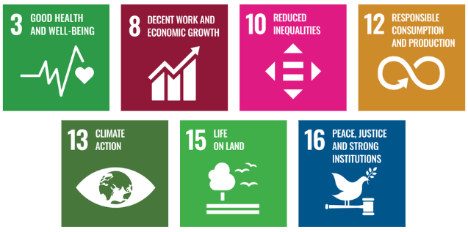
The sustainability objectives and performance targets align with the following Sustainable Development Goals (SDGs):

Responsibilities
- Procurement Team is responsible for integrating responsible sourcing principles into supplier selection, contract terms, and ongoing evaluations.
- Sustainability Team monitors supplier performance on environmental, social, and ethical parameters and supports improvement initiatives.
- Suppliers are expected to comply with RHPL sourcing standards, provide required disclosures, and cooperate during audits and assessments.
- Senior Management ensures oversight, resource allocation, and enforcement of the policy through regular reviews and strategic direction.
- All Employees involved in sourcing or supplier engagement are expected to uphold this policy and report any violations or concerns through established channels.

Review Mechanism
The Sustainable Procurement Policy will be reviewed annually by Procurement officer to ensure its continued relevance, effectiveness, and alignment with evolving regulatory requirements, international best practices, and business priorities. The review process will be overseen by the Procurement and Sustainability Teams, in coordination with relevant department heads.
Supplier compliance will be assessed through regular audits, sustainability scorecards, and feedback mechanisms. Findings from these reviews will inform corrective actions, supplier engagement plans, and policy updates. Any significant updates or improvements to the policy will be approved by senior management and communicated across the supply chain.
Effective Date | : 01.11.2025
Next Review Date | : 01.11.2026
Revision No. | : 01

Approved By:

Employee Acknowledgment Form
I hereby acknowledge that I have read and understood the Sustainable Procurement Policy of RAVINDRA HERAEUS PVT. LTD. I am aware of the company’s commitment to ethical, transparent, and sustainable sourcing practices across all materials and services procured.
I understand that sustainable procurement involves respecting human rights, avoiding materials associated with conflict or unlawful activities, ensuring fair labor conditions throughout the supply chain, and complying with all relevant environmental and social regulations. I recognize that maintaining these standards is a collective responsibility that supports the integrity and sustainability of our operations.
By signing this document, I confirm my commitment to uphold responsible sourcing practices, promptly report any concerns related to sourcing through the designated channels, and actively participate in all required training and awareness programs. I affirm my role in helping RHPL build a supply chain grounded in ethics, accountability, and social and environmental responsibility.
Employee Name | :
Employee ID | :
Department | :
Signature | :

